This is the folder structure. Controller are used for functions, Models are used for classes. And view are used windows forms

**Root -> DbConnection**

This function connects the project with the Mysql database. Usually the port can be 3306. Mine is 3309 change it according to your XAMPP port number.

**Model -> User**

**Model -> Admin**

**Model -> Attendee**

**Model -> Organizers**

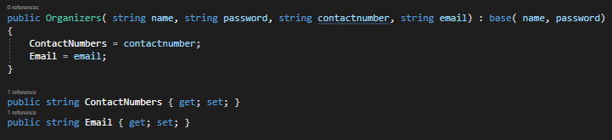

The user class is made as the abstract class cause its only purpose is to provide with the constructor. And Attendee, organizers and Admin Inherit name and password from user.

**View -> signup**

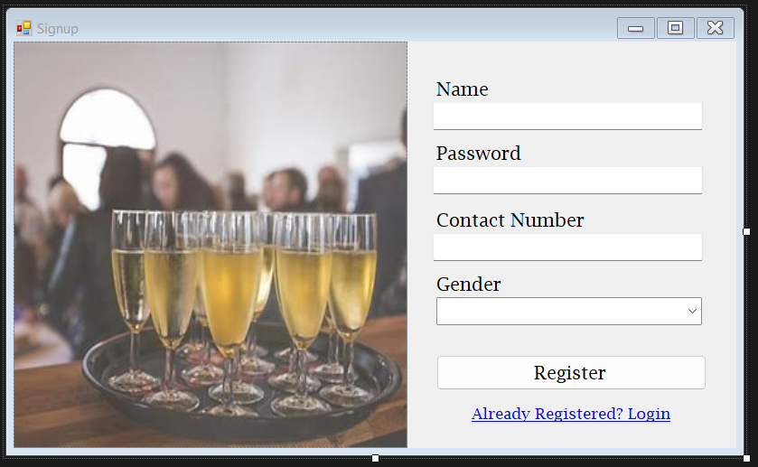

**View -> form1**

**View -> Form1 -> Label Link (first time here? register)**

The link takes for the sign up page

**View -> Signup -> Label Link**

**View -> Signup -> Signup Button**

It gathers the user input for name, password, contact and gender. Then check if its null or not the using the Attendee Class make an object of Attendee and its passed to the function in AttendeeController named as addAttendee which requires an attendee class

**Controller -> AttendeeController -> addAttendee**

First we call the class name DbConnection to get the connection string. We get a Attendee object to the function. First we need to make a try & catch if any exception handling needed. We call the MySqlConnection and we give the connection string to connect to the database. We open the connection and we write the Sql query to add attendee to the database. using sqlCommand we are creating the command to the pass to the database. Then we add the parameters we have from the user input to the command and then we excute the command and if it execute we give an MessageBox with the result.

**View->Form1->LoginButton**

Get user name and password and send to the controller and get the user password. If it returns a password that means user is active. If its null there is no user. Then check weather the received password matched with input password if its true hide form1 and open the dashboard. If the null then try for admin authentication

**Model->Admin**

This is the admin authentication which returns the role

**Controller->AttendeeController->getAttendeePassword**

The attendee controller

**View->AddOrganizer**

View->AddOrganizer->AddOrganizerButton

It take the user input and store as a Orgernizer object. Then passed to the function in OrganizerController. Then it clears all the iput fields

This function get the an Organizer object. The Connects to SQL and input the user inputs to the parameters in the query. And its executed. Exception handling also done for any SQL Exceptions

**Model->Event**

create event model. And an organization connected to Event

**View->Form1**

Authenticating Organizer to there dashboard. By getting the password and checking it with the received password

**Controller->OrganizersController**

This function is used to fetch the Organizers password to authenticate it

**Model->Session**

This Static class is used to save a logged in user data. SO when needed throughout the application the data will be saved and will not have any issues finding the authenticated user. Next I am going to add it when the user gets login to save the user data

**View->Form1**

**Controller -> OrganizerController -> getOrganizerId**

**Controller-> AttendeeController -> getAttendeeId**

**View->OrganizerDashboard**

The design consist of two panels. First panel will contain buttons and second panel screens

**View->OrganizerDashboard**

this function would request a Form type to enter as a object. And it would remove and existing Ui and Add the selected UI to the second pannel

Model->Event

Creation of Event model so can create object and be used in functions

**View->OrganizerDashboard**

Making the btn for navigation

**View->Create Event**

**Controller->OrganizerController**

**Controller->EventController**

**Views -> EditEvent**

**Controller->EventController**

**Views -> EditEvent**

**Controller -> EventController**

**View->DeleteEvent**

**Controller -> EventController**

**Model -> Ticket**

View -> AddTicket

Controller -> TicketController

View -> Edit Ticket

Controller ->TicketController

View -> Edit Ticket

Controller -> TicketController

View -> AttendeeDashboard

View -> purchaseTicket

Controller -> EventController

